|  |  |  |  |  |  |
| --- | --- | --- | --- | --- | --- |
| ID | Type | Name | Amount | Income/amount | Over budget |
| 0123 | Monthly | Test | 1000$ | 133$ | True |
| 0124 | Yearly | Week 1 | 7000$ | 25$ | False |
| 0125 | Weekly | Big Paycheck | 2000$ | 1000$ | True |
|  |  |  |  |  |  |
|  |  |  |  |  |  |

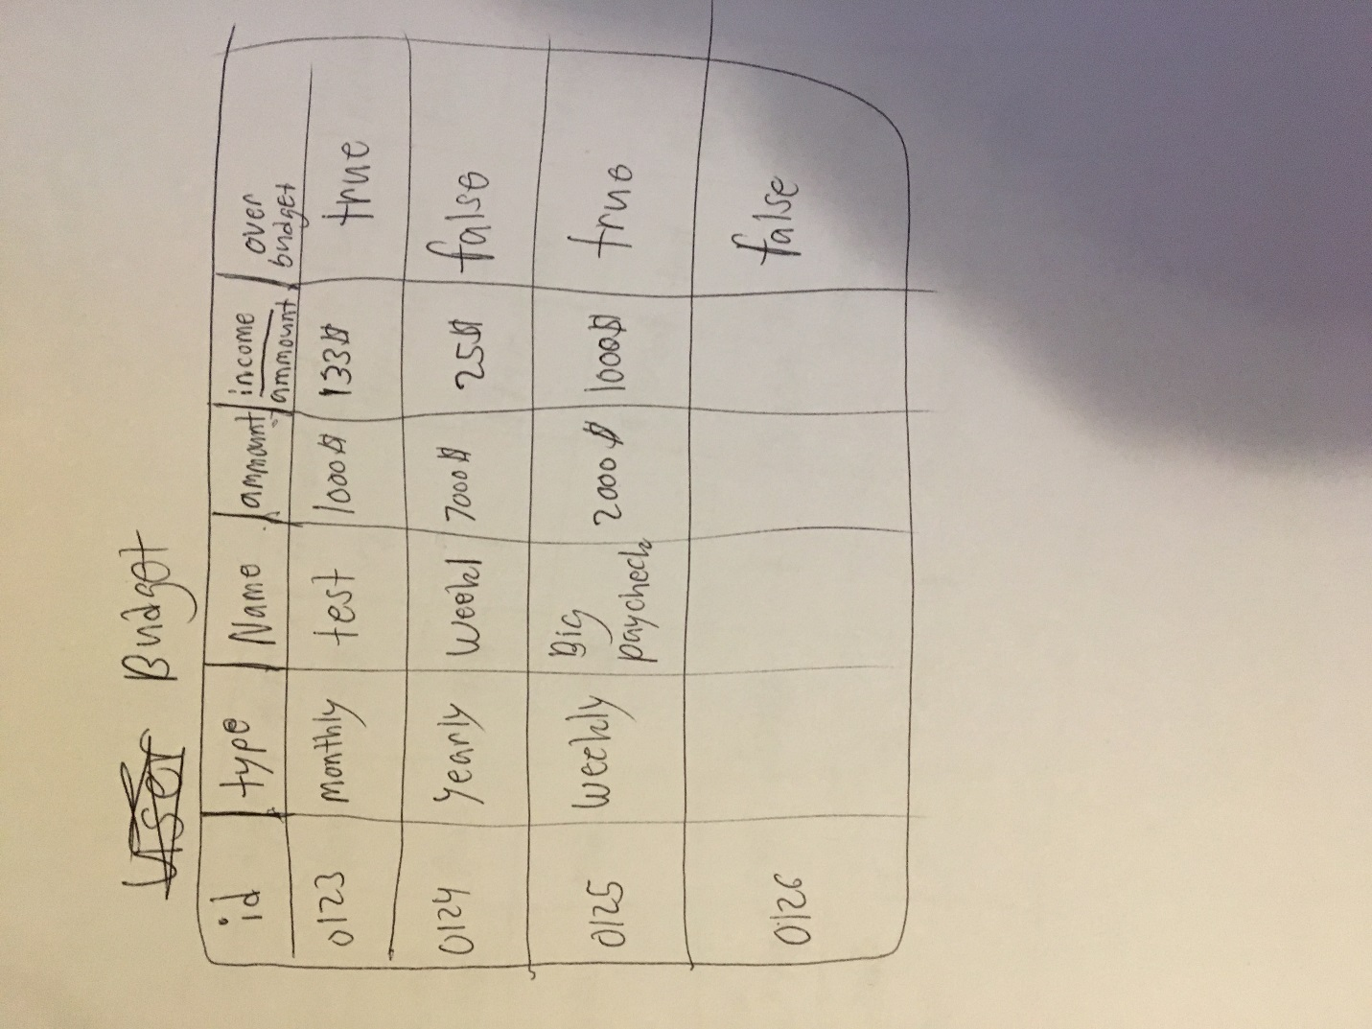

|  |  |  |  |  |  |  |
| --- | --- | --- | --- | --- | --- | --- |
| Name | Type | Price | Amount | Date | Budget | Picture |
| Burger King Meal | Food | 5.99$ | 2 | 4/1/2018 | Test | False |
| Water Bottle | Food | 10.99$ | 1 | 1/2/2018 | Week1 | True |
| Meds | Meds | 20.59$ | 1 | 1/2/2018 | Test | False |
| New Hyundai | Car | 5000$ | 1 | 5/1/2019 | Big Paycheck | True |
| Student Loan | Loan | 99.50$ | 1 | 2/1/2018 | Week1 | False |

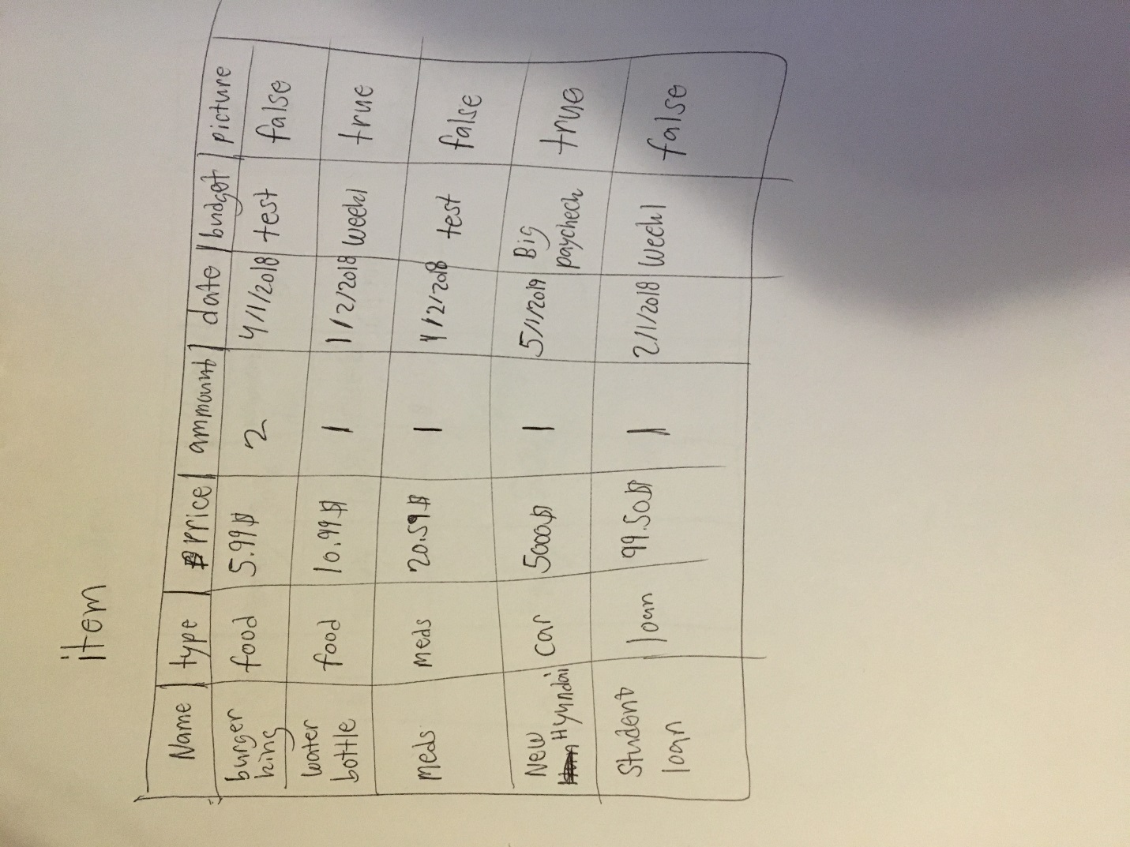

|  |  |  |  |  |  |
| --- | --- | --- | --- | --- | --- |
| ID | Type | Reminder% | Name | Sound | Budget Name |
| 53 | Monthly | 30% | Payments Due | Bell | Test |
| 61 | Weekly | 10% | Careful | Chime | Big Paycheck |
| 20 | Yearly | 50% | Family | Ring | Week1 |

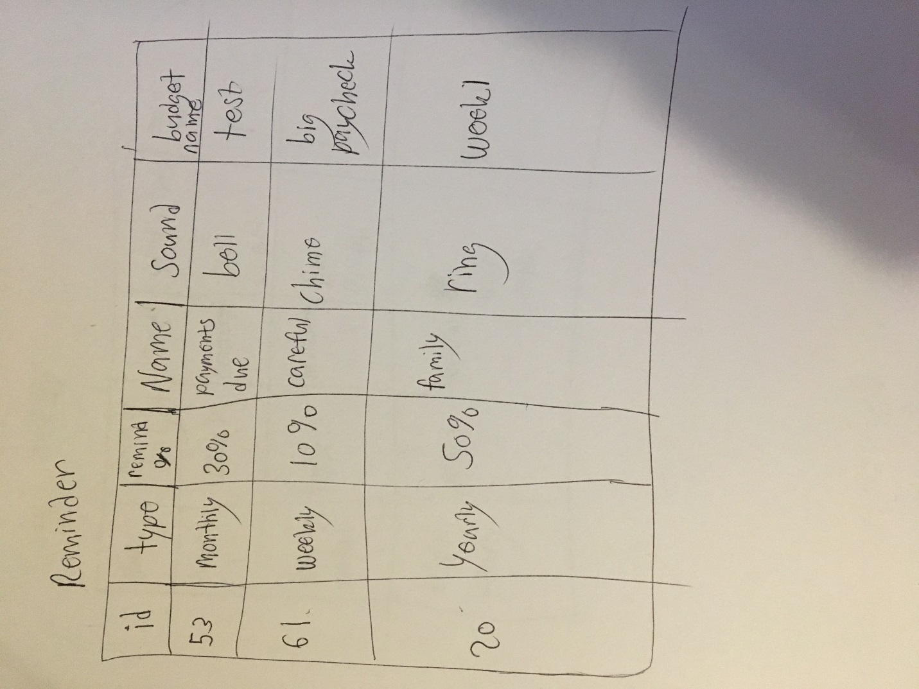

|  |  |  |  |  |
| --- | --- | --- | --- | --- |
| Name | Name Of Budget | Layout | Graph Type | Main Color |
| Display 1 | Week 1 | Centered | Pie Chart | Red |
| Display Week 1 | Test | Horizontal | Bar Graph | Blue |
| Display Yearly | Year 1 | Vertical | Bar Graph | Green |

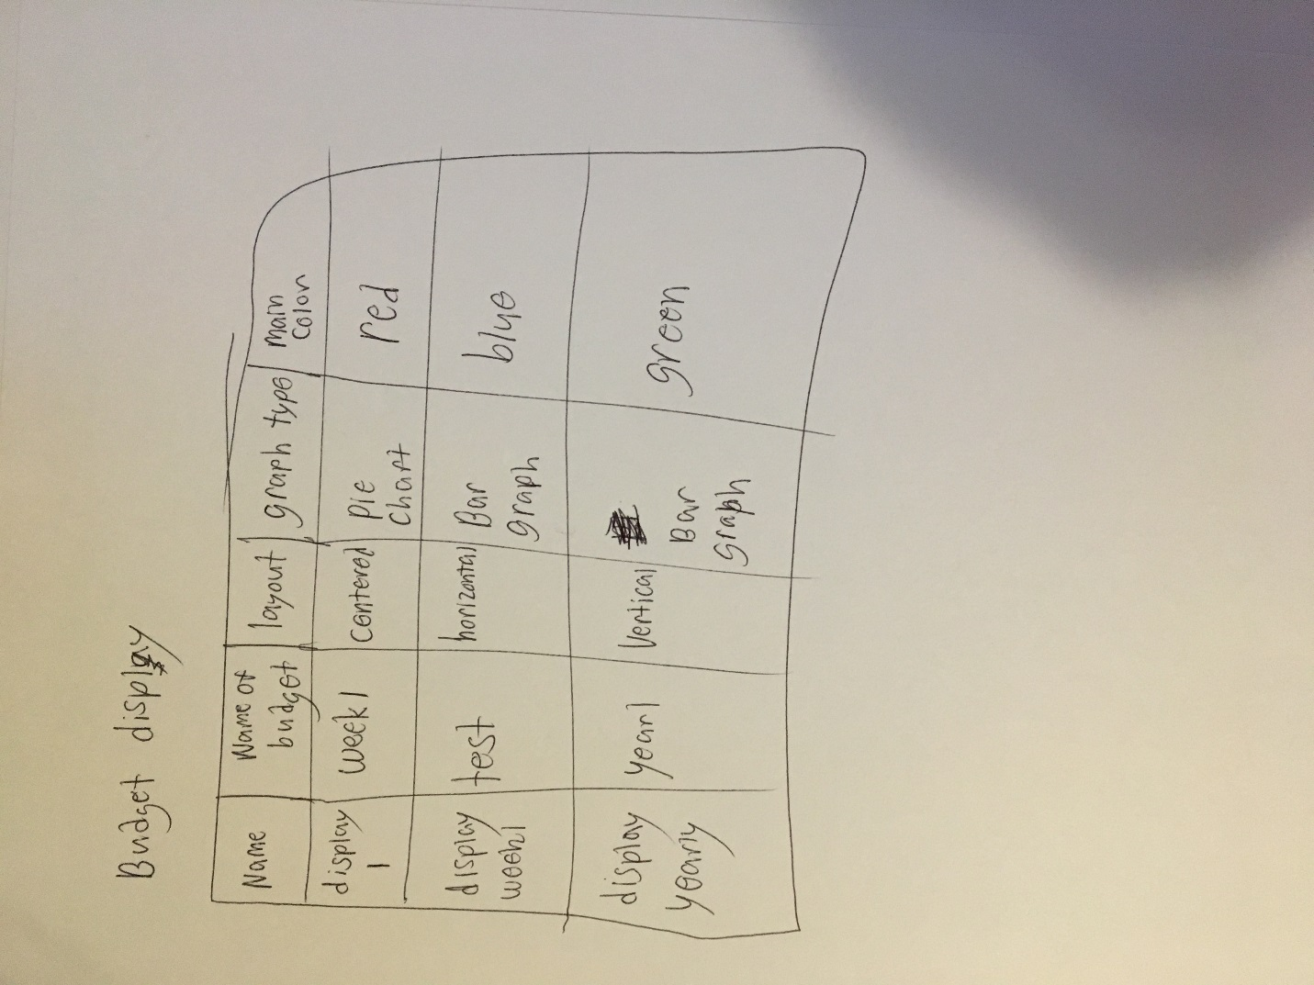

|  |  |  |  |  |  |  |  |  |
| --- | --- | --- | --- | --- | --- | --- | --- | --- |
| Username | First Name | Last Name | Budget amount | Income amount | Savings amount | Number of bank accounts | Amount in each account | Password |
| John Doe | John | Doe | 20,000$ | 80,000$ | 10,000$ | 3 | 20,000. 500. 100 | janeDoe |
| Jane Doe | Jane | Doe | 100,000$ | 1,000,000 | 100$ | 0 | 0 | JohnDoe |
| Bob Smith | Bob | Smith | 300$ | 30,000$ | 3000$ | 1 | 5000$ | Bobby |